Student Name: Harmanpreet Kaur
Student id: 991855668
GitHub link: https://github.com/PreetHaarman/Lab5-JoinDomain

Remote Domain Join from a CSV File

Introduction:
Joining computers to a domain one at a time through System Properties is slow and error-prone when there are many machines. The script in this report automates the task: it reads a list of computer names from a CSV file, connects to each computer remotely, joins it to the Harman.powershell.com domain, restarts it when a restart is required, verifies the result, and produces a report showing which computers were successfully joined.

Lab Environment and Prerequisites

Preparation on the client (SERVER3), run once as Administrator:
Test-Connection 192.168.1.20 -Count 2
Resolve-DnsName Harman.powershell.com
Enable-NetFirewallRule -DisplayGroup "Windows Management Instrumentation (WMI)"

Input CSV File
List of computers is stored in a csv file called Computers.csv. There is one column in the file named ComputerName. The name or IP address of each computer that I want to add to the domain is listed in a row.
Example: ComputerName SERVER3
Using the Import-Csv command, the script reads the computer list. I can add more computers to the CSV file without editing the script, if I need to.

Running the Script with Enter-PSSession from VS Code
The script is run on the domain controller through a PowerShell remoting session opened from the VS Code terminal on the host laptop. VS Code is started with "Run as administrator", and the terminal is opened in the folder that contains Join-ComputersToDomain.ps1 and Computers.csv.

PowerShell Script
<#
.SYNOPSIS
Remotely joins multiple computers, listed in a CSV file, to an Active Directory domain
and generates a report of the results.

.DESCRIPTION
This script reads a list of computer names from a CSV file and, for each computer:
1. Connects to it remotely (WMI) to confirm it is reachable and check its current domain.
2. Skips it if it is already a member of the target domain (no restart required).
3. Joins it to the domain with Add-Computer, optionally placing it in a specific OU.
4. Restarts it (a restart is required for a domain join to take effect) and waits
for it to come back online.
5. Reconnects to verify that the computer is now a member of the domain.

When all computers have been processed, the script displays a summary and exports a
CSV report showing which computers were successfully joined.

Credentials are never stored in the script. They are requested securely with
Get-Credential when not supplied as parameters.

Requirements:
- Windows PowerShell 5.1 (Add-Computer is not available in PowerShell 7).
- Run as Administrator on a computer that can reach the targets (e.g. the DC).
- DNS on each target computer must point to the domain controller.
- Each target must allow remote WMI ("Windows Management Instrumentation (WMI)"
firewall rules enabled) and have a local administrator account.

.PARAMETER CsvPath
Path to the CSV file containing the computers to join. The file must have a column
named "ComputerName".

.PARAMETER DomainName
Fully qualified name of the domain to join. Default: Harman.powershell.com

.PARAMETER OUPath
Optional distinguished name of the OU for the new computer accounts, for example
"OU=Workstations,DC=Harman,DC=powershell,DC=com". If omitted, computers are placed
in the default Computers container.

.PARAMETER DomainCredential
Domain account with permission to join computers to the domain.
If omitted, you are prompted for it.

.PARAMETER LocalCredential
Local administrator account that exists on the target computers.
If omitted, you are prompted for it.

.PARAMETER ReportPath
Path of the CSV report to create. Default: .\DomainJoinReport_<date-time>.csv

.PARAMETER RestartTimeoutSeconds
How long to wait for each computer to come back online after restarting. Default: 600

.EXAMPLE
Join all computers listed in Computers.csv:
PS> .\Join-ComputersToDomain.ps1 -CsvPath .\Computers.csv

.EXAMPLE
Join computers and place them in the Workstations OU:
PS> .\Join-ComputersToDomain.ps1 -CsvPath .\Computers.csv -OUPath "OU=Workstations,DC=Harman,DC=powershell,DC=com"

.EXAMPLE
Preview what the script would do without changing anything:
PS> .\Join-ComputersToDomain.ps1 -CsvPath .\Computers.csv -WhatIf

.NOTES
Author: Harman
Created: 2026-10-19
Version: 1.0
Last Modified: 2026-10-19
Change Log:
1.0 - Initial release

.LINK
https://learn.microsoft.com/powershell/module/microsoft.powershell.management/add-computer
#>

#Requires -Version 5.1
#Requires -PSEdition Desktop
#Requires -RunAsAdministrator

#Parameters
[CmdletBinding(SupportsShouldProcess = $true)]
param(
[Parameter(Mandatory = $true)]
[ValidateScript({ Test-Path -Path $_ -PathType Leaf })]
[string]$CsvPath,

[Parameter()]
[ValidateNotNullOrEmpty()]
[string]$DomainName = 'Harman.powershell.com',

[Parameter()]
[string]$OUPath,

[Parameter()]
[System.Management.Automation.PSCredential]$DomainCredential,

[Parameter()]
[System.Management.Automation.PSCredential]$LocalCredential,

[Parameter()]
[string]$ReportPath = (Join-Path -Path (Get-Location) -ChildPath ("DomainJoinReport_{0:yyyyMMdd_HHmmss}.csv" -f (Get-Date))),

[Parameter()]
[ValidateRange(60, 3600)]
[int]$RestartTimeoutSeconds = 600
)

#Functions

function Import-ComputerList {
<#
.SYNOPSIS
Reads computer names from the CSV file and removes blanks and duplicates.
#>
param(
[Parameter(Mandatory = $true)]
[string]$Path
)

$rows = Import-Csv -Path $Path

if (-not $rows) {
throw "The CSV file '$Path' is empty."
}
if ($rows[0].PSObject.Properties.Name -notcontains 'ComputerName') {
throw "The CSV file '$Path' must contain a column named 'ComputerName'."
}

$rows |
ForEach-Object { "$($_.ComputerName)".Trim() } |
Where-Object { $_ } |
Sort-Object -Unique
}

function Get-RemoteDomainStatus {
<#
.SYNOPSIS
Connects to a remote computer with WMI and returns its name and domain membership.
Throws an error if the computer cannot be reached.
#>
param(
[Parameter(Mandatory = $true)]
[string]$Computer,

[Parameter(Mandatory = $true)]
[System.Management.Automation.PSCredential]$Credential
)

Get-WmiObject -Class Win32_ComputerSystem -ComputerName $Computer -Credential $Credential -ErrorAction Stop |
Select-Object -Property Name, Domain, PartOfDomain
}

function New-JoinResult {
<#
.SYNOPSIS
Creates one row for the final report.
#>
param(
[string]$Computer,
[string]$PreviousDomain = '',
[string]$Status,
[bool]$Restarted = $false,
[bool]$JoinedToDomain = $false,
[string]$Message = ''
)

[pscustomobject]@{
ComputerName = $Computer
PreviousDomain = $PreviousDomain
Status = $Status
Restarted = $Restarted
JoinedToDomain = $JoinedToDomain
Message = $Message
Timestamp = (Get-Date).ToString('yyyy-MM-dd HH:mm:ss')
}
}

function Join-RemoteComputer {
<#
.SYNOPSIS
Joins one remote computer to the domain, restarts it, verifies the join and
returns a report row.
#>
param(
[Parameter(Mandatory = $true)] [string]$Computer,
[Parameter(Mandatory = $true)] [string]$Domain,
[Parameter(Mandatory = $true)] [System.Management.Automation.PSCredential]$DomainCred,
[Parameter(Mandatory = $true)] [System.Management.Automation.PSCredential]$LocalCred,
[string]$OU,
[int]$TimeoutSeconds = 600
)

# Step 1: Connect remotely and check the current domain membership.
try {
$before = Get-RemoteDomainStatus -Computer $Computer -Credential $LocalCred
}
catch {
return New-JoinResult -Computer $Computer -Status 'Unreachable' `
-Message "Could not connect: $($_.Exception.Message)"
}

$previousDomain = if ($before.PartOfDomain) { $before.Domain } else { "Workgroup: $($before.Domain)" }

# Step 2: Skip computers that are already members of the target domain.
if ($before.PartOfDomain -and $before.Domain -eq $Domain) {
return New-JoinResult -Computer $Computer -PreviousDomain $previousDomain -Status 'AlreadyJoined' `
-JoinedToDomain $true -Message 'Already a member of the domain. No restart required.'
}

# Step 3: Join the computer to the domain.
$joinParams = @{
ComputerName = $Computer
LocalCredential = $LocalCred
DomainName = $Domain
Credential = $DomainCred
Force = $true
PassThru = $true
ErrorAction = 'Stop'
}
if ($OU) { $joinParams.OUPath = $OU }

try {
$joinResult = Add-Computer @joinParams
if (-not $joinResult.HasSucceeded) {
return New-JoinResult -Computer $Computer -PreviousDomain $previousDomain -Status 'JoinFailed' `
-Message 'Add-Computer reported that the join did not succeed.'
}
}
catch {
return New-JoinResult -Computer $Computer -PreviousDomain $previousDomain -Status 'JoinFailed' `
-Message $_.Exception.Message
}

# Step 4: Restart the computer (required for the join to take effect) and wait for it.
try {
Restart-Computer -ComputerName $Computer -Credential $LocalCred -Force `
-Wait -For Wmi -Timeout $TimeoutSeconds -Delay 5 -ErrorAction Stop
}
catch {
return New-JoinResult -Computer $Computer -PreviousDomain $previousDomain -Status 'RestartFailed' `
-Message "Joined, but the restart could not be confirmed: $($_.Exception.Message)"
}

# Step 5: Reconnect and verify the computer is now a member of the domain.
try {
$after = Get-RemoteDomainStatus -Computer $Computer -Credential $LocalCred
if ($after.PartOfDomain -and $after.Domain -eq $Domain) {
return New-JoinResult -Computer $Computer -PreviousDomain $previousDomain -Status 'Joined' `
-Restarted $true -JoinedToDomain $true -Message "Successfully joined $Domain."
}
return New-JoinResult -Computer $Computer -PreviousDomain $previousDomain -Status 'VerificationFailed' `
-Restarted $true -Message "After restart the computer reports domain '$($after.Domain)'."
}
catch {
return New-JoinResult -Computer $Computer -PreviousDomain $previousDomain -Status 'VerificationFailed' `
-Restarted $true -Message "Restarted, but could not reconnect to verify: $($_.Exception.Message)"
}
}

#Execution Code

# 1. Read the list of computers from the CSV file.
try {
$computers = @(Import-ComputerList -Path $CsvPath)
}
catch {
Write-Error $_.Exception.Message
return
}
Write-Host "Found $($computers.Count) computer(s) in '$CsvPath'." -ForegroundColor Cyan

# 2. Confirm the domain can be resolved in DNS before going further.
try {
Resolve-DnsName -Name $DomainName -ErrorAction Stop | Out-Null
}
catch {
Write-Error "Cannot resolve '$DomainName'. Check that this computer's DNS points to the domain controller."
return
}

# 3. Collect credentials securely (no passwords are stored in the script).
if (-not $DomainCredential) {
$DomainCredential = Get-Credential -UserName "$DomainName\Administrator" `
-Message "Enter a domain account that can join computers to $DomainName"
if (-not $DomainCredential) { Write-Error 'Domain credentials are required.'; return }
}
if (-not $LocalCredential) {
$LocalCredential = Get-Credential -UserName 'Administrator' `
-Message 'Enter a local administrator account that exists on the target computers'
if (-not $LocalCredential) { Write-Error 'Local administrator credentials are required.'; return }
}

# 4. Process each computer.
$results = New-Object System.Collections.Generic.List[object]
$counter = 0

foreach ($computer in $computers) {
$counter++
Write-Progress -Activity "Joining computers to $DomainName" -Status "$computer ($counter of $($computers.Count))" `
-PercentComplete (($counter / $computers.Count) * 100)

if ($PSCmdlet.ShouldProcess($computer, "Join to domain '$DomainName' and restart")) {
Write-Host "[$counter/$($computers.Count)] Processing $computer..." -ForegroundColor Yellow
$result = Join-RemoteComputer -Computer $computer -Domain $DomainName -DomainCred $DomainCredential `
-LocalCred $LocalCredential -OU $OUPath -TimeoutSeconds $RestartTimeoutSeconds
$results.Add($result)

$colour = if ($result.JoinedToDomain) { 'Green' } else { 'Red' }
Write-Host " $($result.Status): $($result.Message)" -ForegroundColor $colour
}
}
Write-Progress -Activity "Joining computers to $DomainName" -Completed

# 5. Generate the report.
if ($results.Count -gt 0) {
$results | Export-Csv -Path $ReportPath -NoTypeInformation -Encoding UTF8

$joined = @($results | Where-Object { $_.JoinedToDomain }).Count
$failed = $results.Count - $joined

Write-Host ''
Write-Host '===== Domain Join Report =====' -ForegroundColor Cyan
$results | Format-Table -Property ComputerName, Status, Restarted, JoinedToDomain, Message -AutoSize -Wrap
Write-Host "Domain : $DomainName"
Write-Host "Total computers : $($results.Count)"
Write-Host "In domain : $joined" -ForegroundColor Green
Write-Host "Failed : $failed" -ForegroundColor $(if ($failed) { 'Red' } else { 'Green' })
Write-Host "Report saved to : $ReportPath" -ForegroundColor Cyan
}

Step 1 – Check connectivity and trust the domain controller
The laptop is not a domain member, so the DC must be added to TrustedHosts before a remoting session can be opened.
Test-Connection 192.168.1.20 -Count 2
Test-NetConnection 192.168.1.20 -Port 5985
Set-Item WSMan:\localhost\Client\TrustedHosts -Value “192.168.1.20” -Concatenate -Force

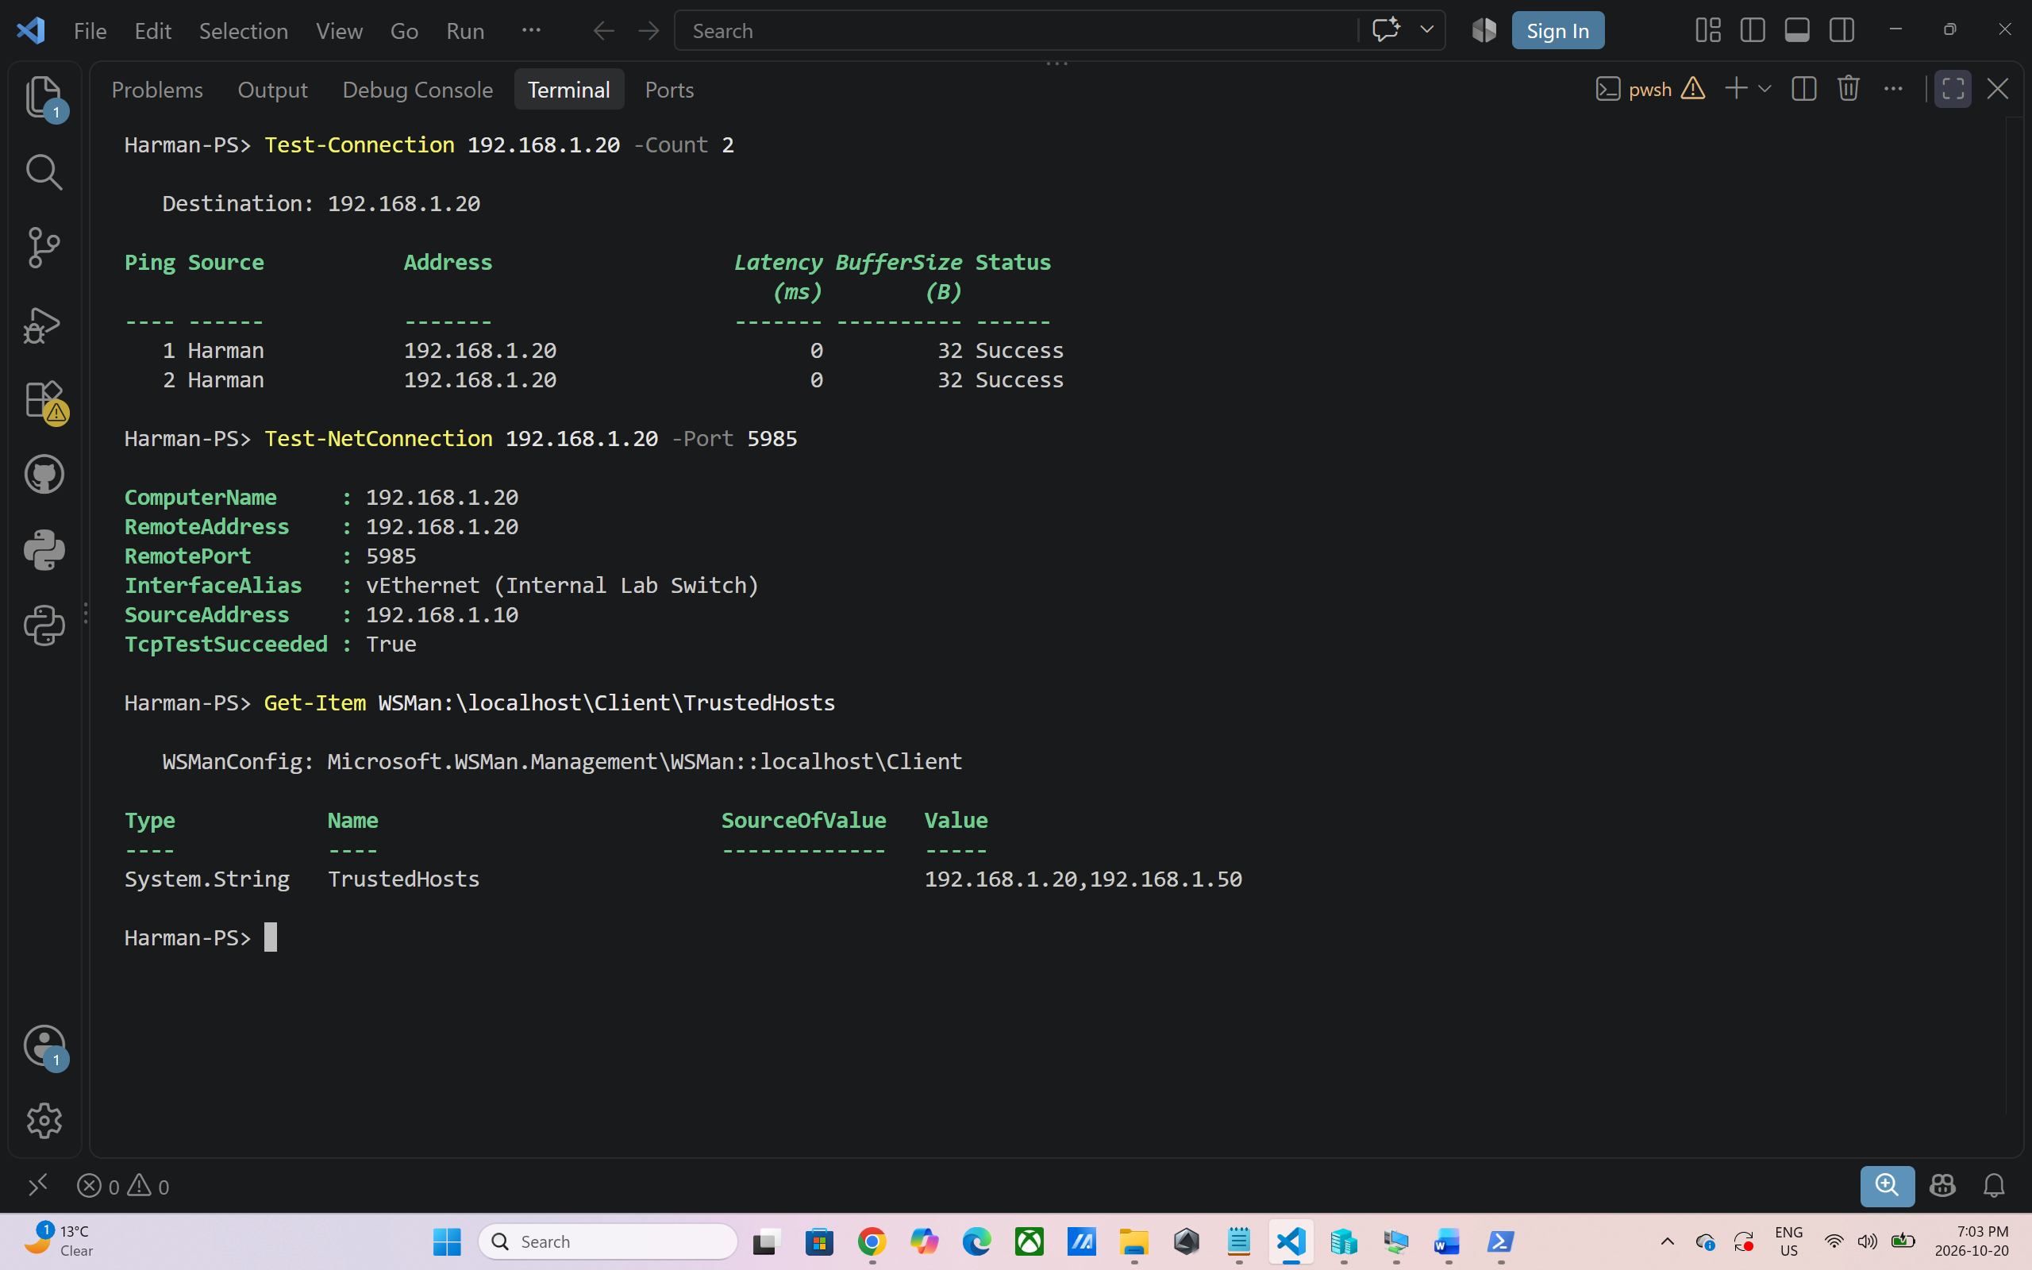

Step 2 – Open a session and copy the files to the DC
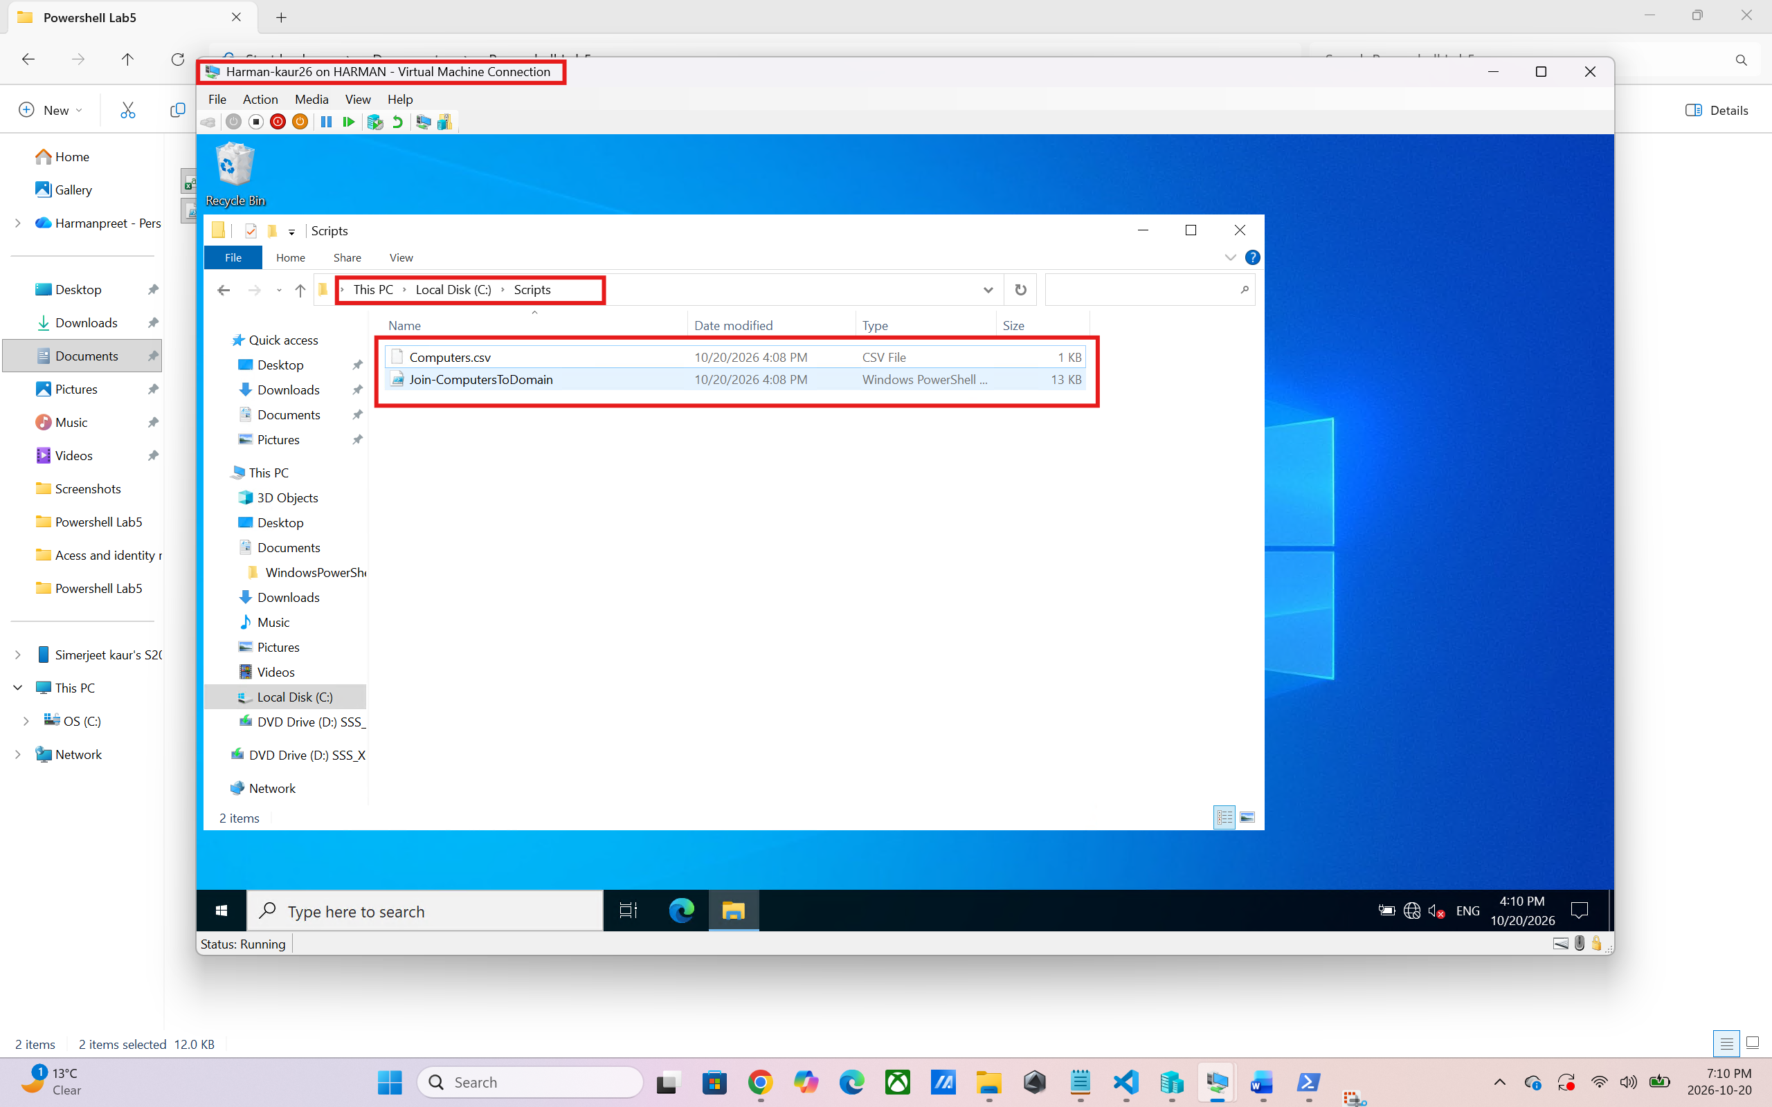

Step 3 – Enter the remote session
Enter-PSSession -ComputerName 192.168.1.20 -credential Harman.powershell.com\administrator
cd C:\Script
function prompt{"Harman-PS> "}
ls
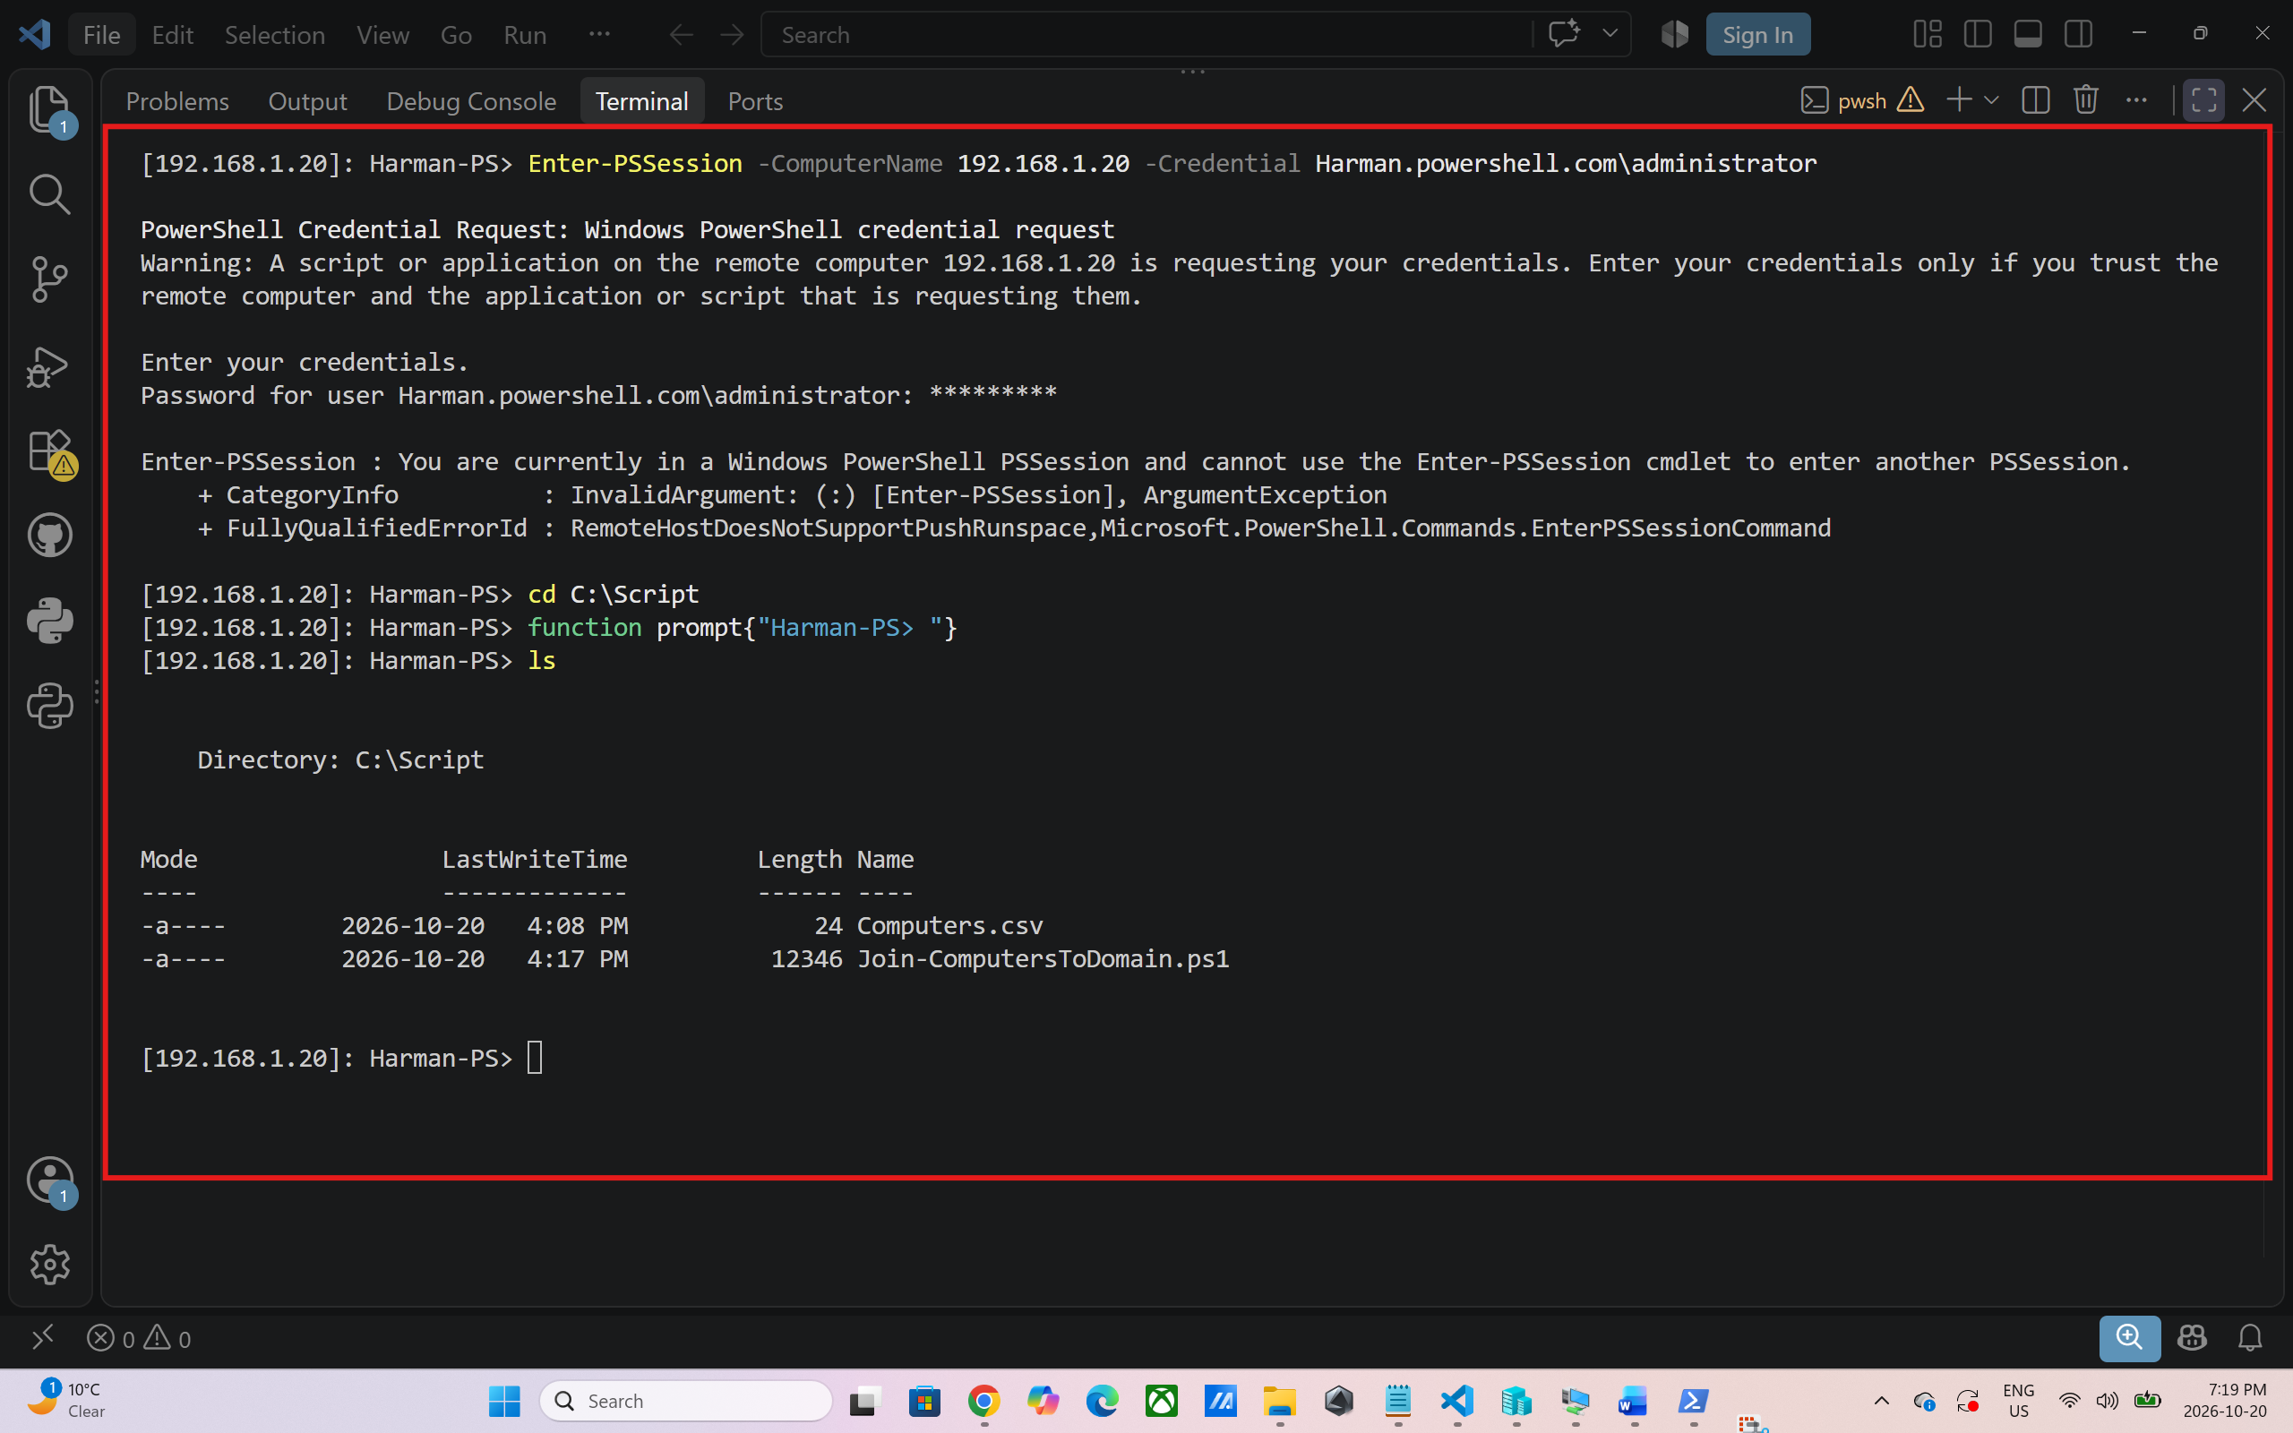

In this step, I connected from the VS Code terminal on my laptop to the Domain Controller using the Enter-PSSession command with the DC’s IP address (192.168.1.20). After I entered the password, the prompt changed to [192.168.1.20]:, which confirmed that I was now working on the Domain Controller instead of my own computer. I then used cd C:\Script to move into the folder where I had saved my files. Finally, I ran ls to list the folder, which showed Computers.csv, the file with the list of computers to join, and Join-ComputersToDomain.ps1, my script.
Step 4 – Join the computers to the domain
$local = Get-Credential "SERVER3\Administrator"
.\Join-ComputersToDomain.ps1 -CsvPath .\Computers.csv -LocalCredential $local
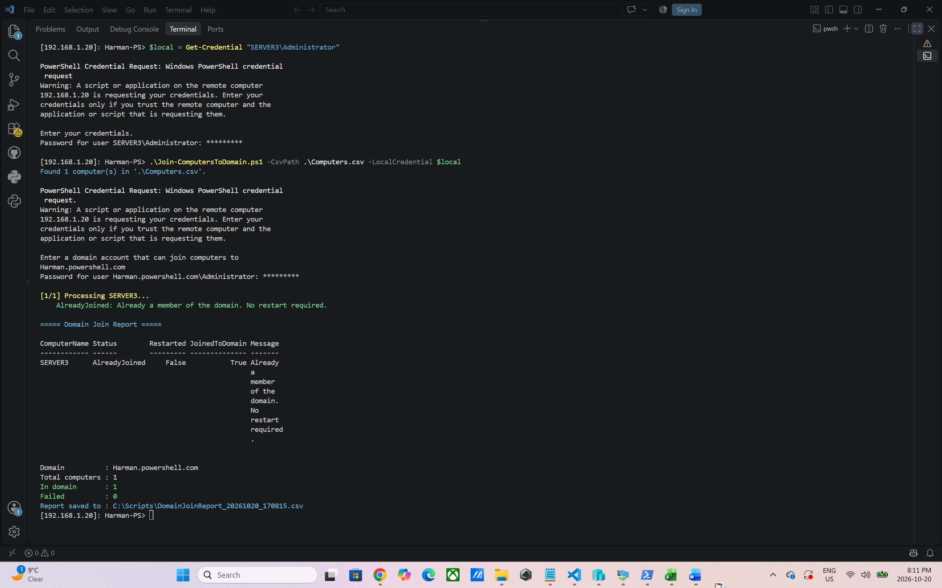

The first command, $local = Get-Credential "SERVER3\Administrator", asks for the password of the local Administrator account on the client computer SERVER3 and saves it securely in a variable called $local. The second command, .\Join-ComputersToDomain.ps1 -CsvPath .\Computers.csv -LocalCredential $local, runs my script. It reads the list of computers from Computers.csv and uses the saved local credential to connect to each computer and join it to the domain
Step 5– Verify the result
Exit
Enter-PSSession 192.168.1.50 -credential Harman.powershell.com\administrator
Hostname
Get-CimInstance Win32_ComputerSystem | Select Name, Domain, PartofDomain
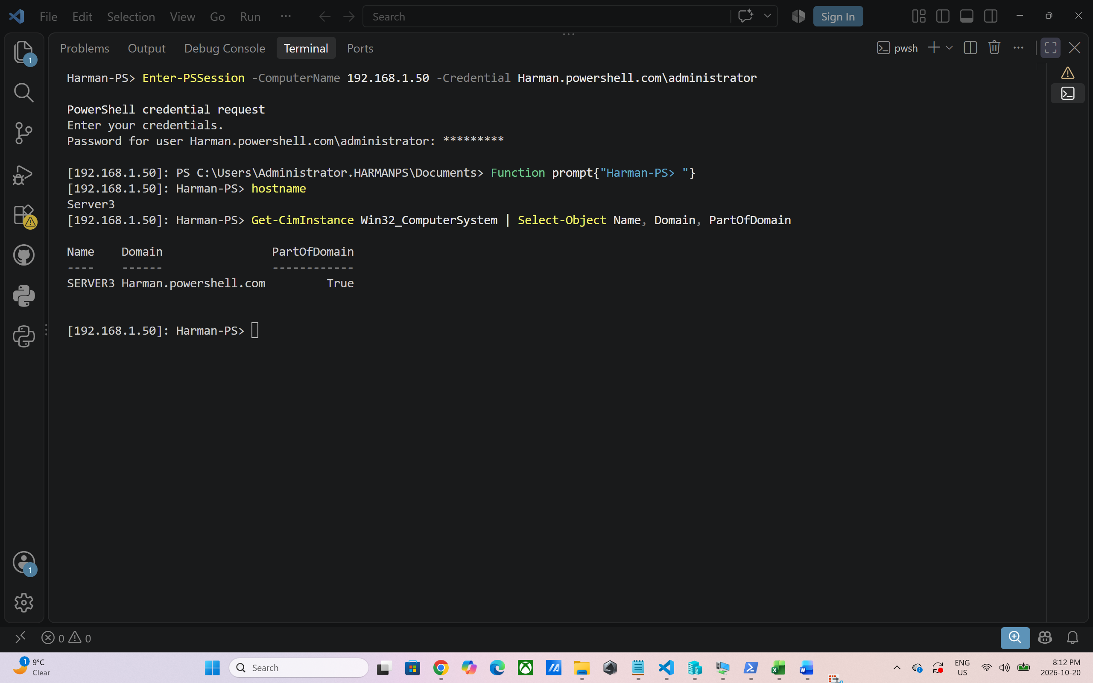

In this step, I verified that the client computer had actually joined the domain. First, I used Exit to leave the remote session on the Domain Controller and return to my laptop. Then I ran Enter-PSSession 192.168.1.50 -Credential Harman.powershell.com\administrator to connect directly to the client computer (192.168.1.50) with the domain administrator account. The prompt path also shows C:\Users\Administrator.Harman, meaning Windows created a profile for the domain account on this computer. After changing the prompt to Harman-PS>, I ran hostname, which returned SERVER3 and confirmed I was on the correct computer. Finally, I ran Get-CimInstance Win32_ComputerSystem | Select Name, Domain, PartOfDomain to check its domain membership. The output shows the name SERVER3, the domain Harman.powershell.com, and PartOfDomain as True. This proves that my script successfully joined the client computer to the domain.
Step 6 – Close the session
exit

How the Script Works
The script follows the course script template (comment-based help, then the Parameters, Functions and Execution Code sections). For each computer in the CSV file it performs these steps:
- Connect: queries Win32_ComputerSystem over WMI to confirm the computer is reachable and read its current domain or workgroup.
- Skip if already joined: a computer that is already in Harman.powershell.com is reported as AlreadyJoined and is not restarted, because no restart is required.
- Join: runs Add-Computer with -ComputerName, -LocalCredential and the domain credential, optionally placing the account in a specific OU with -OUPath.
- Restart: a domain join only takes effect after a restart, so the script runs Restart-Computer -Wait and waits for the computer to come back online.
- Verify: reconnects after the restart and confirms that PartOfDomain is True and the domain is Harman.powershell.com.
- Report: displays a colour-coded summary and exports a CSV report (DomainJoinReport_<date-time>.csv).
Each computer is handled inside its own try/catch blocks, so one unreachable or failed computer does not stop the rest of the list from being processed.

Reflection Summary
This assignment showed me how much time and risk PowerShell can remove from a routine administration task. Joining machines one at a time through the GUI is fine for one computer, but reading the list from a CSV file and looping through it makes the process repeatable and consistent for any number of computers. Running the script from the VS Code terminal on my laptop through Enter-PSSession also showed me how administrators really work: I never had to log into the domain controller's desktop, but I first had to add the DC to TrustedHosts because my laptop is not a domain member. The hardest part was not the Add-Computer command itself but everything around it: the client had to use the domain controller for DNS, remote WMI had to be allowed through the firewall, and a restart is required before the join takes effect. Building in the reachability check, the restart-and-wait step and the post-restart verification taught me that a script should confirm its own results instead of assuming a command worked. As a cyber security student, I also noticed that the course examples stored a domain admin password in plain text and suggested turning off the firewall. I replaced these with Get-Credential prompts and a targeted WMI firewall rule, because automation scripts are often shared or left on servers, and a leaked domain admin password would give an attacker control of the whole domain. Overall, the assignment improved my understanding of Active Directory, PowerShell remoting, error handling with try/catch, and writing scripts that are both useful and secure.

